Videos
Alle Videos sind Eigentum von Tourism Ireland

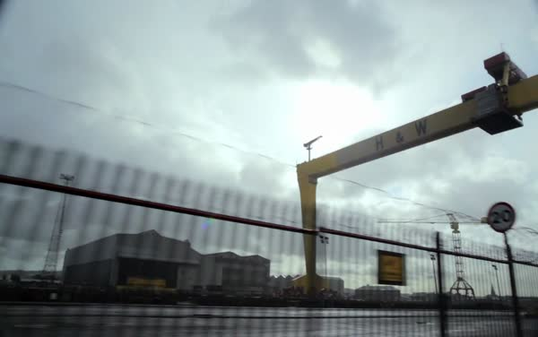

Titanic Belfast
- DOWNLOAD ( 23 Mb)
- 24. Apr. 2012
https://www.youtube.com/watch?v=58pop_NgLi8

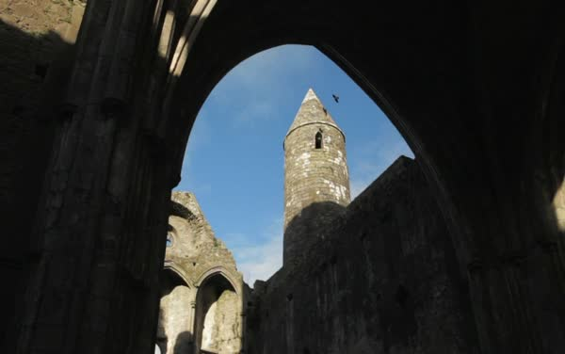

Rock of Cashel
- DOWNLOAD ( 26 Mb)
- 24. Apr. 2012
https://www.youtube.com/watch?v=JD4e0zZstD8

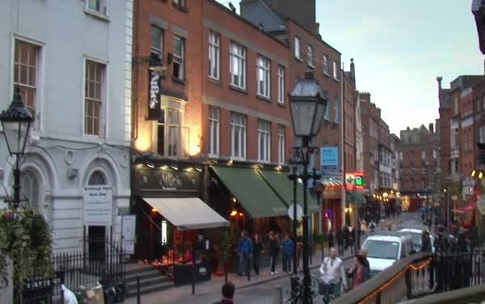

Dublin City
- DOWNLOAD ( 26 Mb)
- 24. Apr. 2012
https://www.youtube.com/watch?v=y7SYNnLF7E8

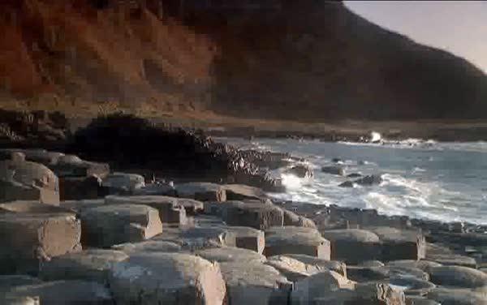

Die Grafschaft Tyrone
- DOWNLOAD ( 16 Mb)
- 29. Feb. 2012
https://www.youtube.com/watch?v=TukzZJb1nsY

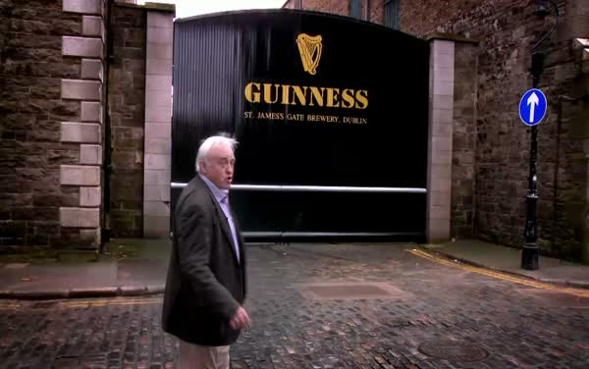

Guinness Storehouse in Dublin
- DOWNLOAD ( 53 Mb)
- 29. Feb. 2012
https://www.youtube.com/watch?v=apYjwskne4g



Sport in Irland
- DOWNLOAD ( 16 Mb)
- 29. Feb. 2012
https://www.youtube.com/watch?v=y8vbx4pWDPw

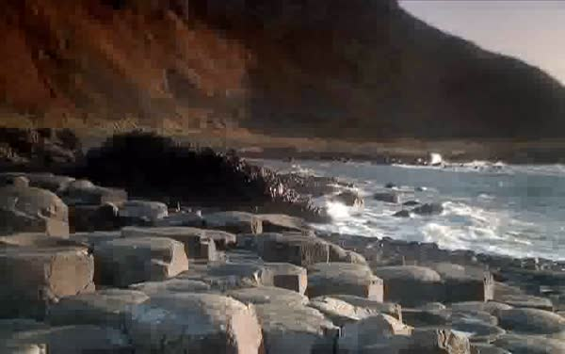

Die Grafschaft Sligo
- DOWNLOAD ( 16 Mb)
- 29. Feb. 2012
https://www.youtube.com/watch?v=C8A6Gdm30z0

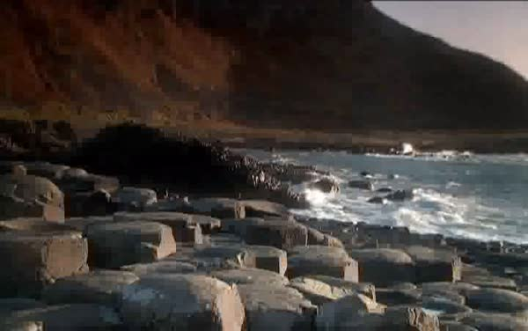

Irlands Landschaften
- DOWNLOAD ( 15 Mb)
- 29. Feb. 2012
https://www.youtube.com/watch?v=8jppYRNXi8I



Food
- DOWNLOAD ( 18 Mb)
- 28. Feb. 2012
https://www.youtube.com/watch?v=SrHeJeW8Jlk

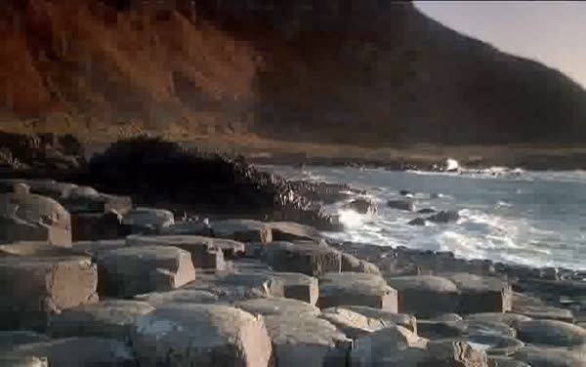

Causeway Coast
- DOWNLOAD ( 16 Mb)
- 28. Feb. 2012
https://www.youtube.com/watch?v=cXav_LjDO18

Die Grafschaft Tipperary
- DOWNLOAD ( 19 Mb)
- 28. Feb. 2012
https://www.youtube.com/watch?v=2dWYJkQlDg0

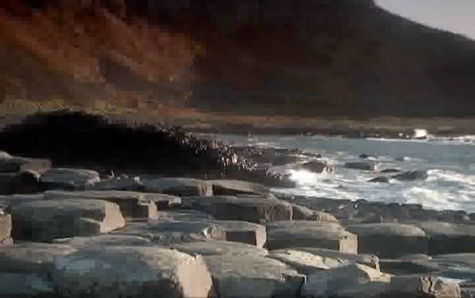

Die Städte Dublin und Belfast
- DOWNLOAD ( 19 Mb)
- 28. Feb. 2012
https://www.youtube.com/watch?v=S0ZvvEI57rs

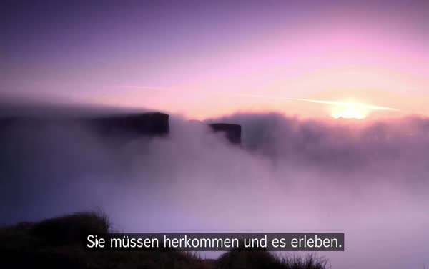

Cliffs of Moher, Co. Clare
- DOWNLOAD ( 11 Mb)
- 28. Feb. 2012
https://www.youtube.com/watch?v=TQUrsGndMC0

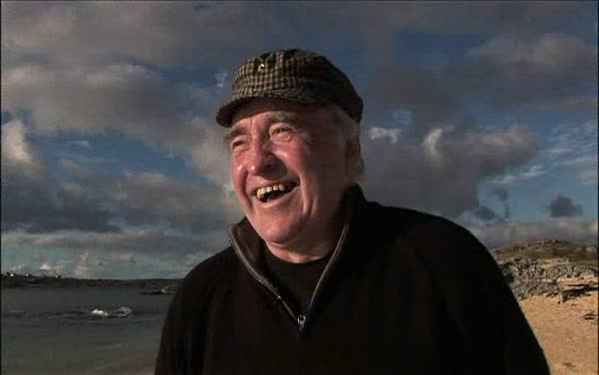

Dublin - Noelle & Hilary
- DOWNLOAD ( 46 Mb)
- 22. Feb. 2012
https://www.youtube.com/watch?v=fo9OLbs8U0A

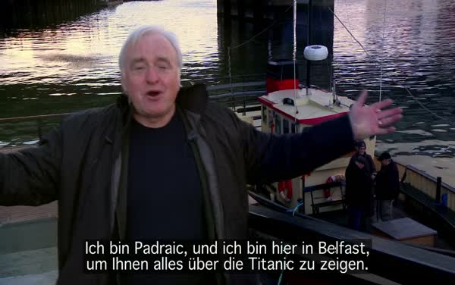

Titanic
- DOWNLOAD ( 80 Mb)
- 17. Jan. 2012
https://www.youtube.com/watch?v=dlFx5ui-MKc

